EXERCISE 4: CREATING AND CONFIGURING A MAVEN PROJECT
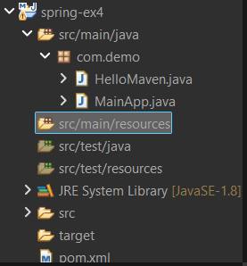
package com.demo;

public class HelloMaven {

public void show() {
System.out.println("Maven Spring Project Working!");
}
}

package com.demo;

public class MainApp {

public static void main(String[] args) {

HelloMaven obj = new HelloMaven();
obj.show();
}
}

<project xmlns="http://maven.apache.org/POM/4.0.0" xmlns:xsi="http://www.w3.org/2001/XMLSchema-instance" xsi:schemaLocation="http://maven.apache.org/POM/4.0.0 https://maven.apache.org/xsd/maven-4.0.0.xsd">
<modelVersion>4.0.0</modelVersion>
<groupId>com.demo</groupId>
<artifactId>spring-ex4</artifactId>
<version>0.0.1-SNAPSHOT</version>
<dependency>
<groupId>org.springframework</groupId>
<artifactId>spring-context</artifactId>
<version>5.3.9</version>
</dependency>
</project>

Output:
